**Project Title** **:** **PetCare+ – Specialized Veterinary Treatment Slot Booking System**

**PHASE 2**

**1.Company Profile Setup**

* What it does: Sets company-wide defaults (name, time zone, currency, language).
* What you need:
  + Company Name: PetCare+ Veterinary Hospital
  + Time Zone: Asia/Kolkata (or your clinic location)
  + Currency: INR ₹
  + Language: English
* How it helps: All reminders, appointment times, and reports will match the clinic’s working region and avoid time mismatches.

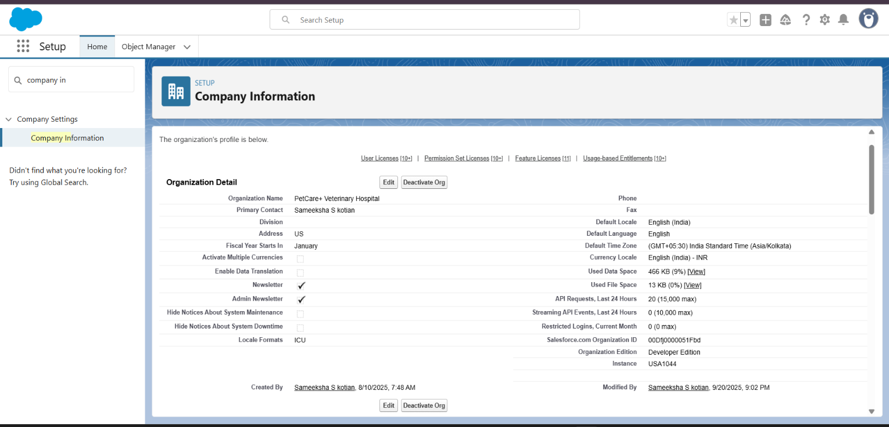

**2. Hours & Holidays**

* What it does: Defines working hours and off-days.
* What you need:
  + Business Hours: Mon–Sat, 9 AM – 7 PM
  + Holidays: Sundays + public holidays
* How it helps: Prevents owners from booking appointments outside real clinic timings.

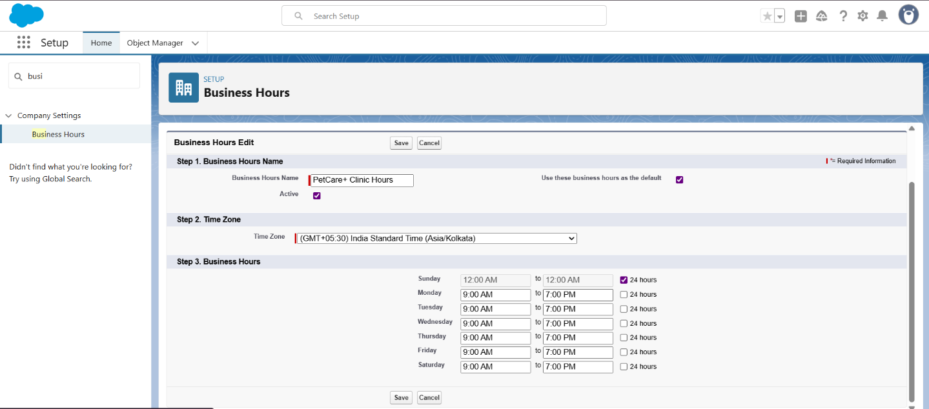

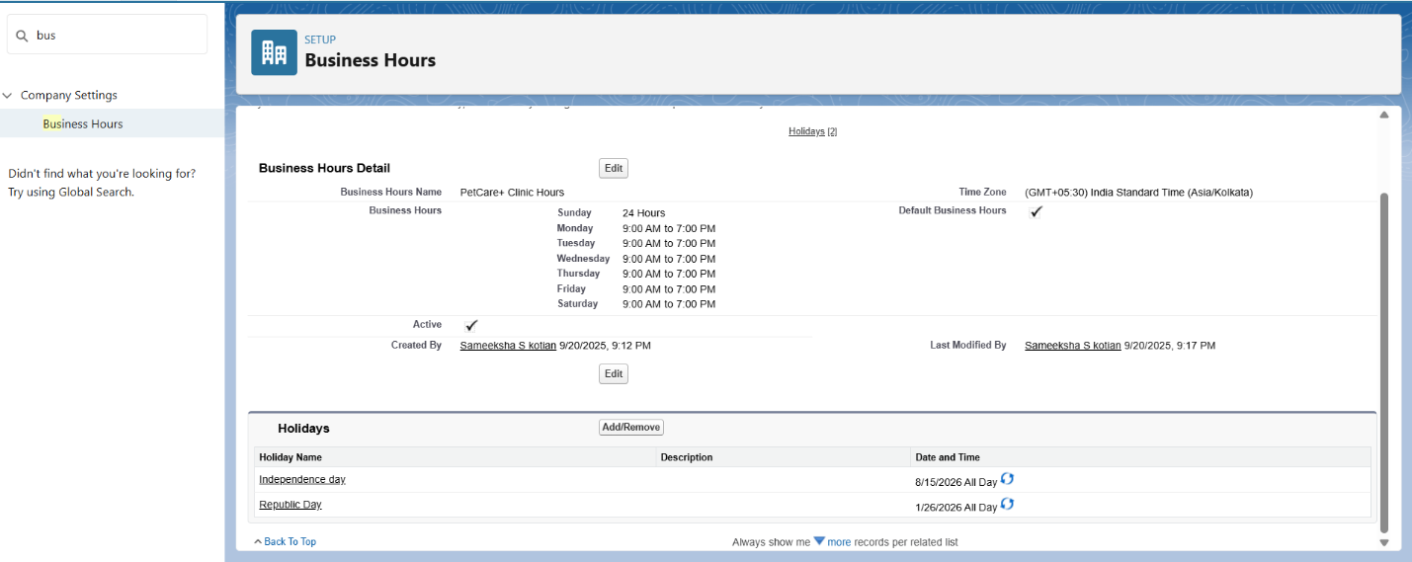

**3.User Setup & Licenses**

* What it does: Creates accounts for staff who will log into Salesforce.
* What you need (Users):
  + 1 Clinic Administrator (System Admin license)
  + 2–3 Specialist Doctors (Salesforce Platform license) – Ortho, Cardio, Neuro
  + 1 Receptionist (System admin license)
* How it helps: Each staff member logs in separately with their own role, avoiding mix-ups.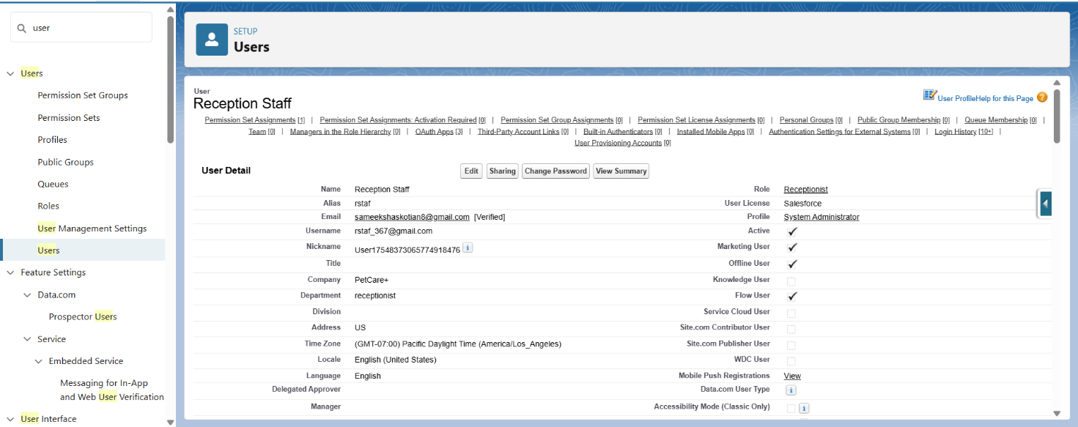

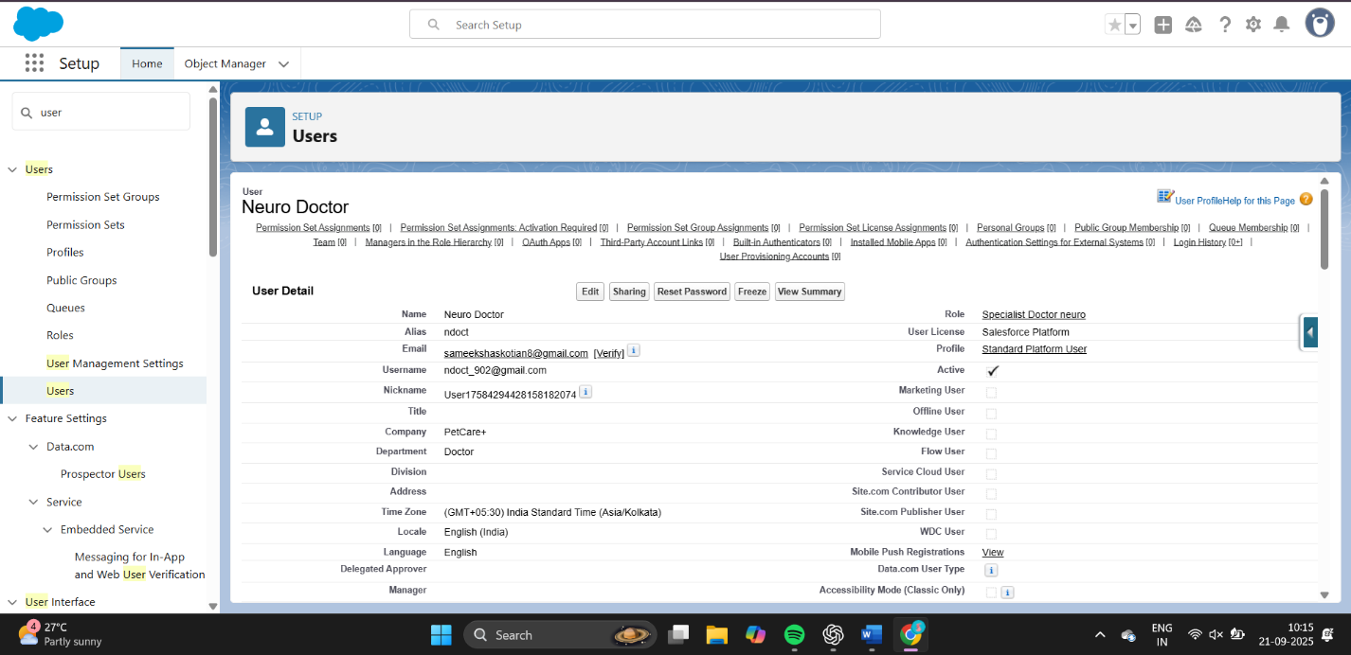

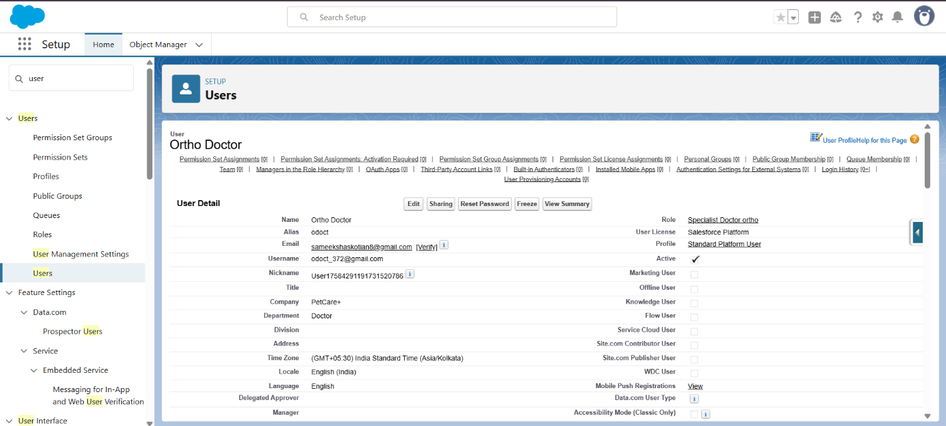

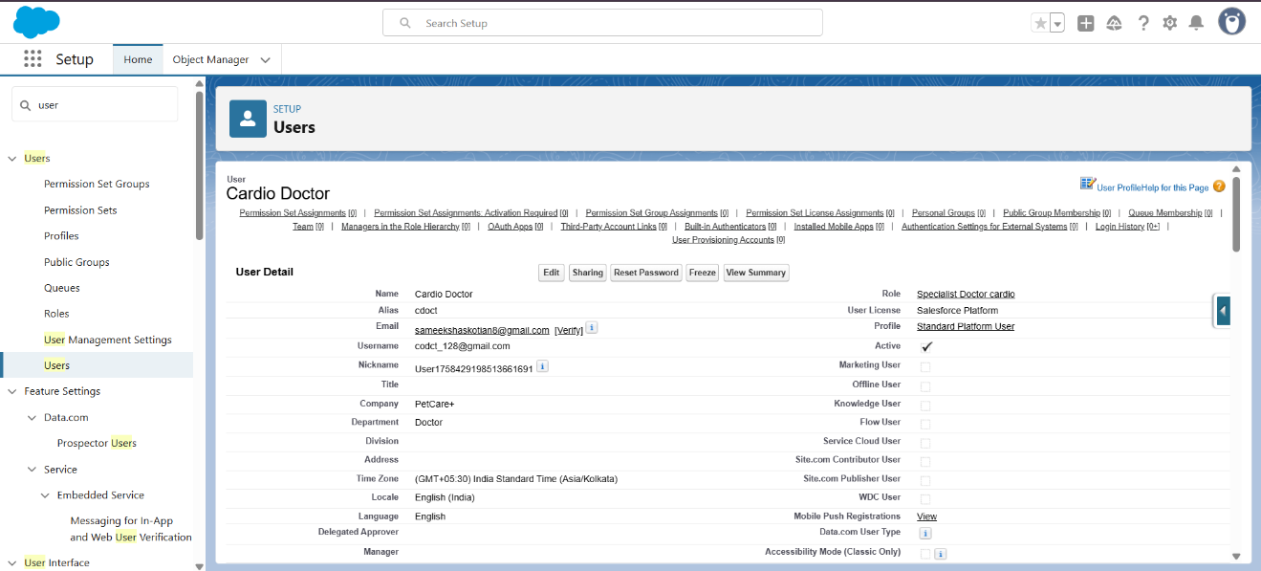

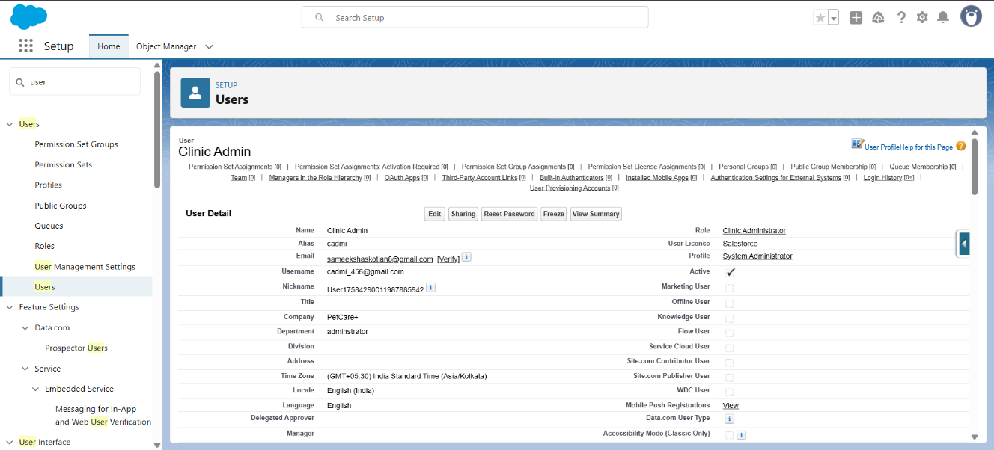

**4.Profiles**

* What it does: Defines what each type of user can do.
* What you need (Profiles):
  + System Admin Profile – full control.
  + Doctor Profile – Can view their patients, update treatment notes, but no slot booking.
  + Receptionist Profile – Can book/cancel slots, view pet/owner details, but no access to medical notes.
* How it helps: Ensures users only see/do tasks relevant to them.

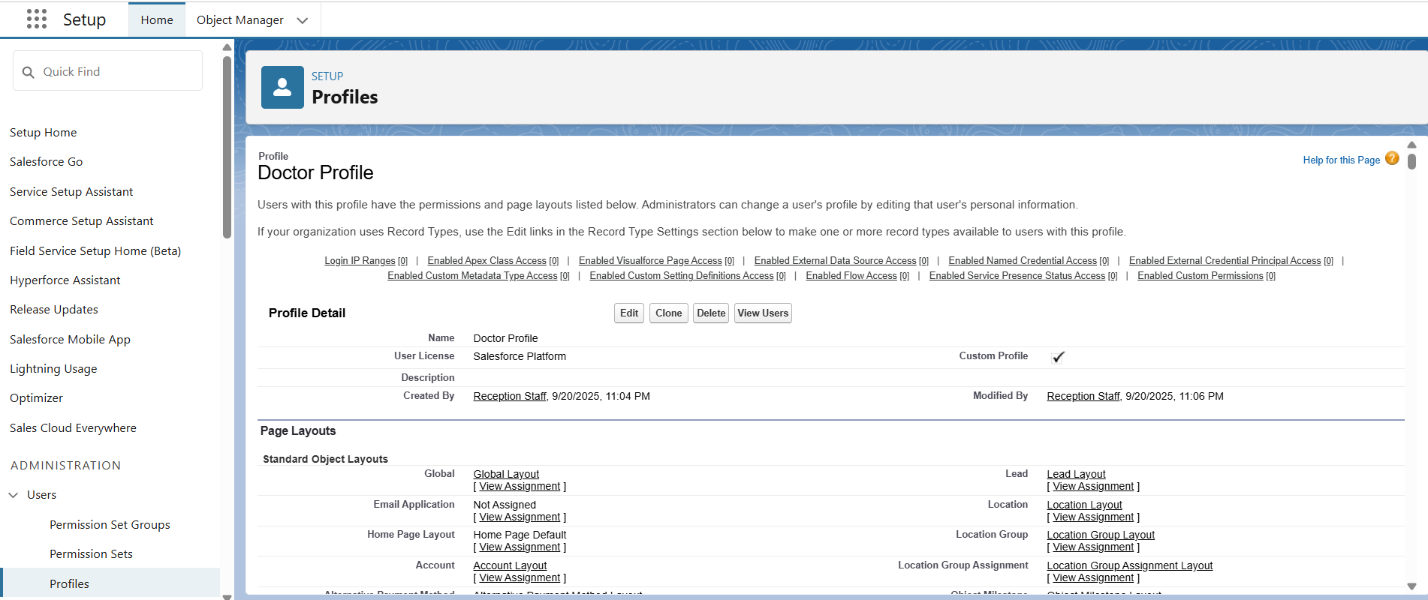

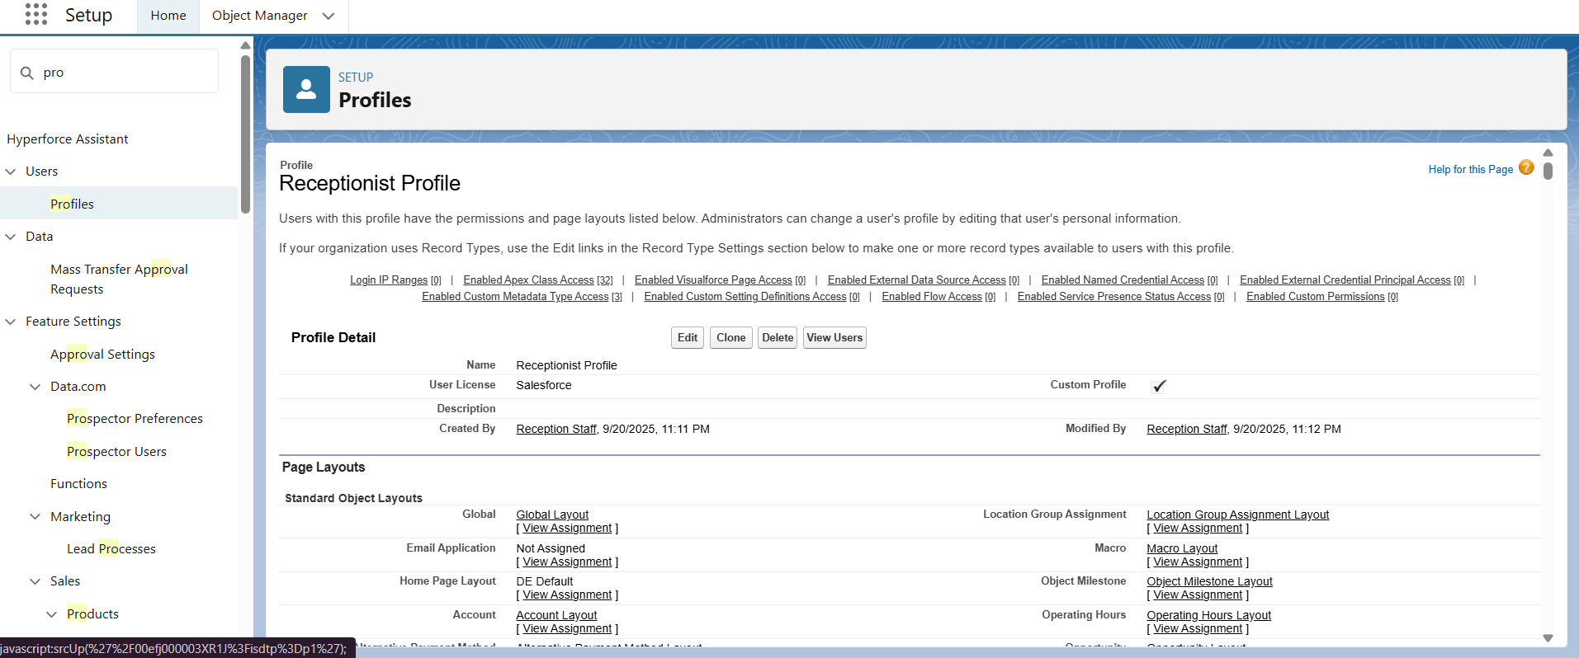

**5.Roles**

* What it does: Sets up hierarchy for data visibility.
* What you need (Roles):
  + Clinic Administrator
  + Specialist Doctor
  + Receptionist
* How it helps: Admin sees everything, Doctors see their own patients/slots, Receptionist sees appointments but not confidential data.

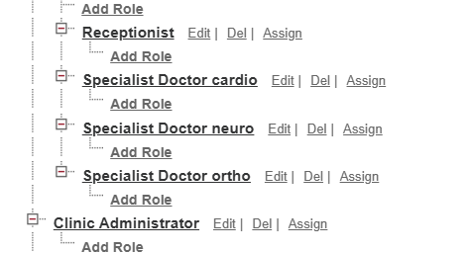

**6.Permission Sets**

* What it does: Grants extra permissions on top of profiles.
* What you need (Permission Sets):
  + “Report Access” → If receptionists also need to view dashboards.
  + “Medical Notes Update” → If certain doctors need extra access beyond default.
* How it helps: Avoids creating too many profiles. You give extra access only when needed.

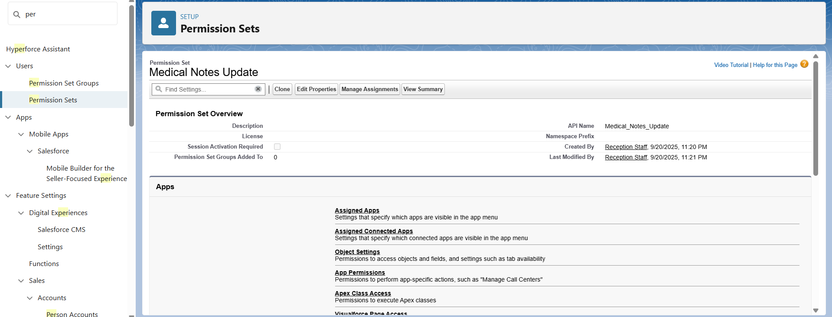

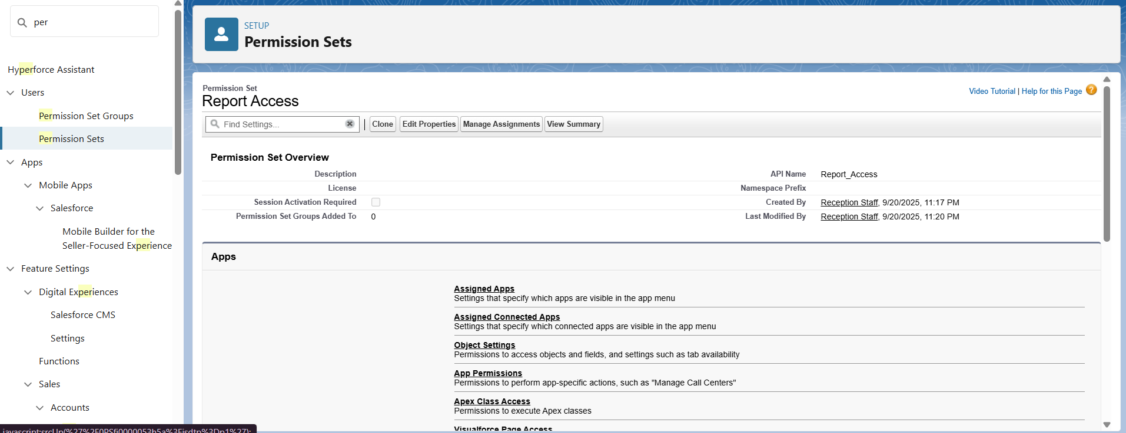

**7.OWD (Organization-Wide Defaults)**

* What it does: Controls default sharing for all records.
* What you need:
  + Pet & Owner Records → Private (only assigned staff can see).
  + Appointment Slots → Public Read/Write (so receptionists can manage them).
* How it helps: Protects sensitive medical info but still keeps slots visible to staff.

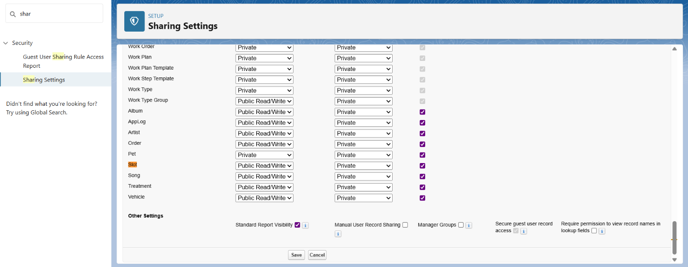

**8.Login Access Policies**

* What it does: Controls login security.
* What you need:
  + Enable MFA (Multi-Factor Authentication).
  + Restrict IP ranges (logins allowed only from clinic network, optional).
* How it helps: Keeps clinic data safe from unauthorized access.

